Committed to delivering a safe environment
www.safegolf.org
for golf

Is something worrying you?
Do you need someone to talk to?
Speak to your club welfare officer
Lesanne76@msn.com
07929117198
Lesley Johnson

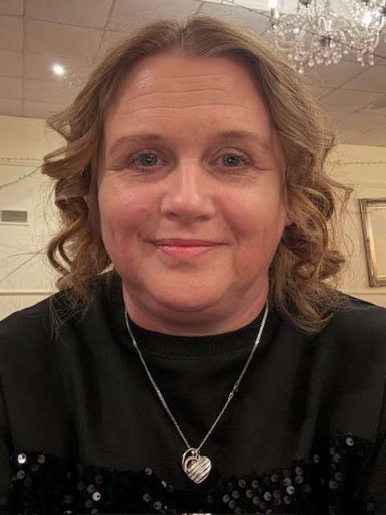

PHOTO

Click to add photo
Alternatively, you can speak to someone at
ChildLine 0800 1111
ABOUT ME

Hi I am Lesley, I am very approachable so if you need to speak about anything please feel free to contact me or speak to me in person.
NSPCC 0808 800 5000
England Golf 01526 351851
Club
WELFARE
officer

